- Gender Distribution of PASC Cases Pie Chart:
This pie chart shows the percentage (%) distribution of males and females within the PASC dataset. It also includes the precise count of individuals in each category.
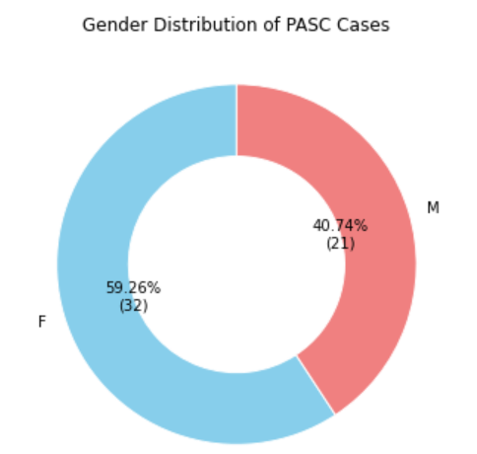
- Distribution Of PASC Category:
This bar graph shows the percentage (%) distribution of PASC (short, Intermediate and, long term) Category. It also includes the precise count of individuals in each category.
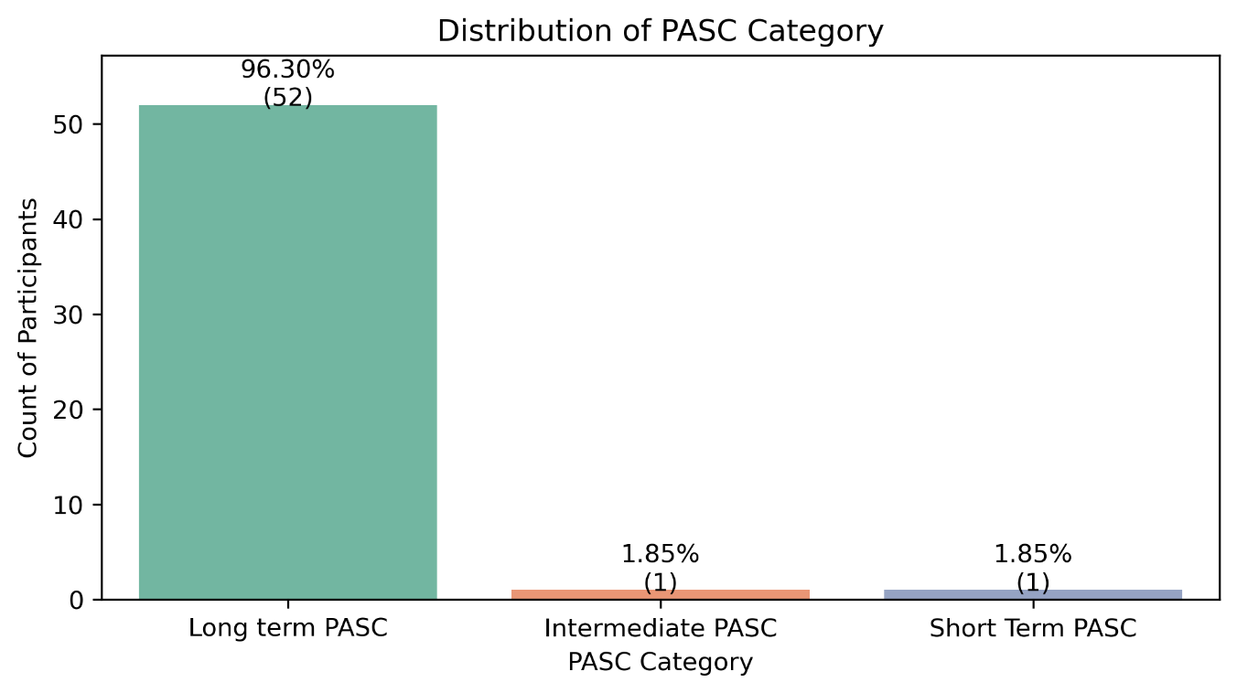
- Half -Year-Wise Distribution Of PASC Cases:
This bar graph shows the percentage (%) distribution of Half-Year-Wise PASC cases. It also includes the precise count of individuals in each category.
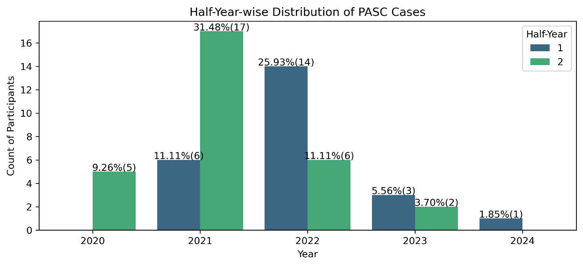
- Half -Year-Wise Distribution Of PASC Cases:
This bar graph shows the percentage (%) distribution of Year-Wise PASC cases. It also includes the precise count of individuals in each category.
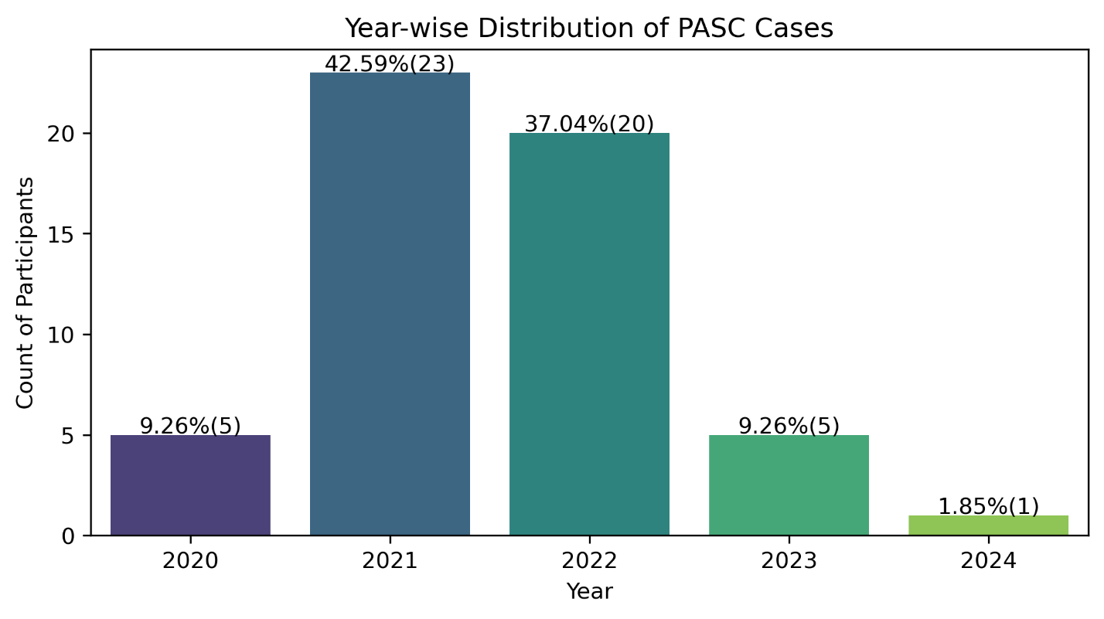
- Distribution Of Neutrophil Levels by Gender & Age Groups in PASC Cases:
This bar graph illustrates the Neutrophil levels (%) across different age groups and genders. The gray horizotal box represent the normal range of neutrophil levels. From the graph, it is evident that females generally have higher neutrophil levels compared to males.
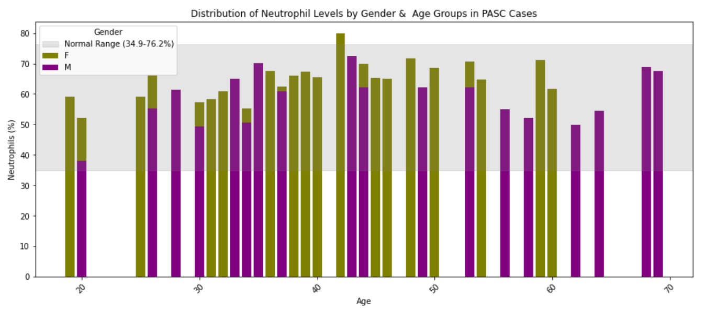
- Distribution Of Lemphocyte Levels by Gender & Age Groups in PASC Cases:
This bar graph displays the Lymphocyte levels (%) categorized by age and gender. The gray horizontal bar signifies the normal range of lymphocyte levels. From the graph, it is noticeable that in most cases, males have higher lymphocyte levels compared to females.
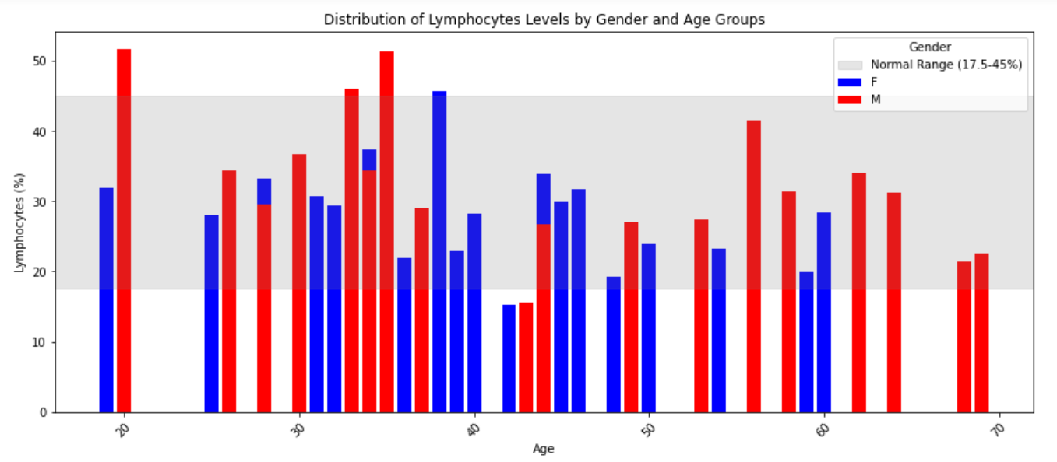
- Box Plot of Neutrophils % level vs Gender in PASC Cases:
This box plot displays the Neutrophil levels (%) vs gender.
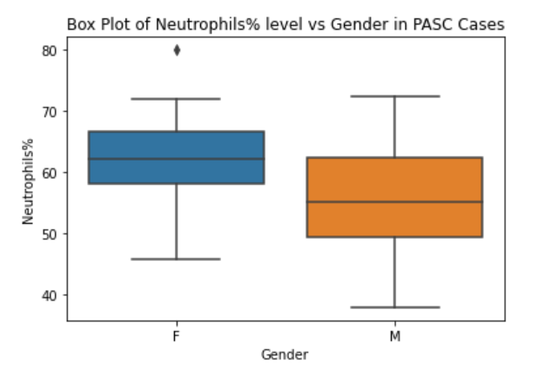
- Box Plot of Lymphocytes % level vs Gender in PASC Cases:
This box plot displays the Lymphocytes levels (%) vs gender.
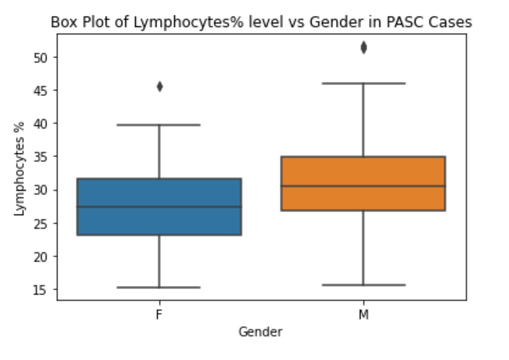

9.NLR Distribution with Age Group in PASC Cases:
This bar graph illustrates the Neutrophil-to-Lymphocyte Ratio (NLR) across different age groups. The normal range for NLR is typically between 1 and 2. A ratio between 2 and 3 is considered raised, while a ratio between 3 and 4 is significantly raised. The graph clearly indicates that from ages 40 to 59, the NLR ratio is significantly raised. 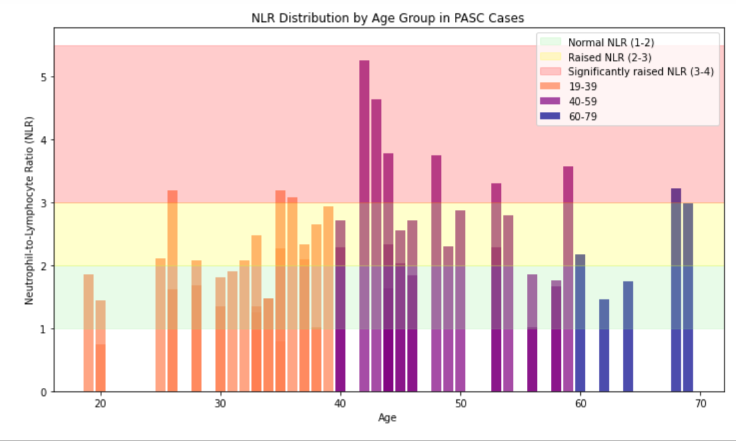

10. Correlation Between CBC Parameters and PACS Cases General Symptoms:
This heatmap illustrates correlation between CBC Parameters and PASC Cases General Symptoms.
- Hemoglobin, Hematocrit, and RBC are strongly correlated with each other.
- Neutrophils and Lymphocytes show a moderate positive correlation.
- Platelets and Weakness have a moderate positive correlation
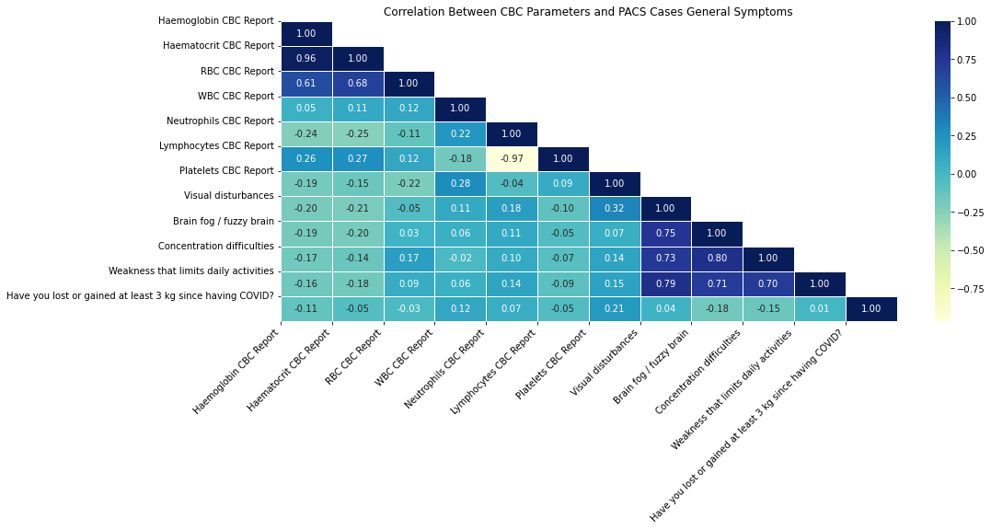

11. Correlation Between CBC Parameters and PACS Cases Respiratory Symptoms:
This heatmap illustrates correlation between CBC Parameters and PASC Cases Respiratory Symptoms
- Respiratory symptoms: There are strong positive correlations among most respiratory symptoms (cough, nasal issues, voice issues, throat issues, throat restriction, palpitations, loss of smell, loss of taste).
- CRP and respiratory symptoms: CRP, an inflammation marker, shows moderate to strong positive correlations with most respiratory symptoms, suggesting inflammation is associated with these symptoms.
- Lymphocytes and respiratory symptoms: Lymphocytes (a type of white blood cell) show weak to moderate negative correlations with most respiratory symptoms.

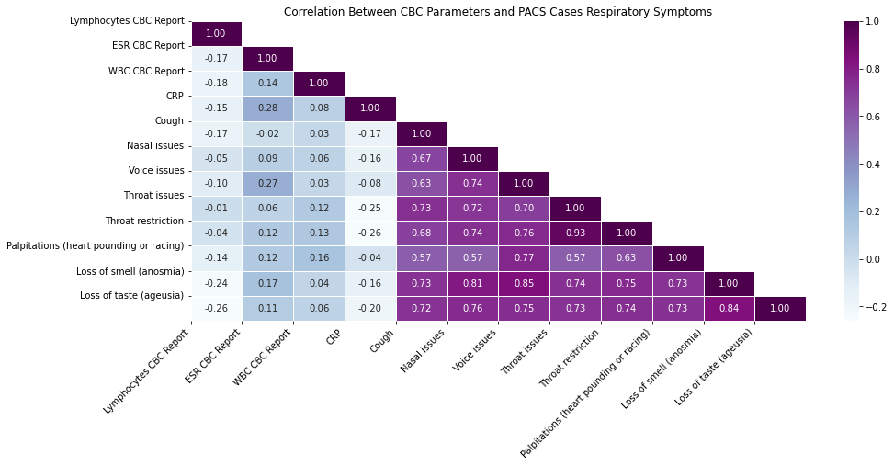

12. Distribution of COVID Vaccine dose 1 Products by Percentage:
These are 6 pie chart of Distribution of COVID Vaccine dose 1 Products by Percentage
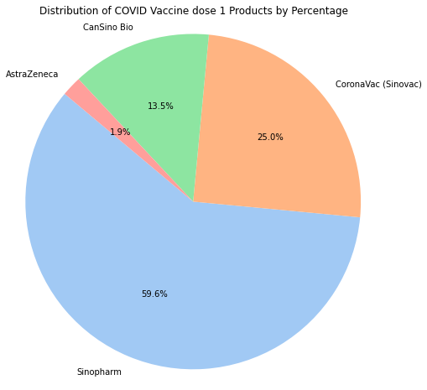
13. Distribution of COVID Vaccine dose 2 Products by Percentage:
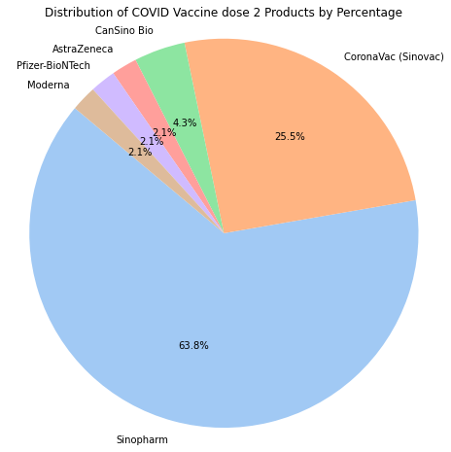
14. Distribution of COVID Vaccine dose 3 Products by Percentage:
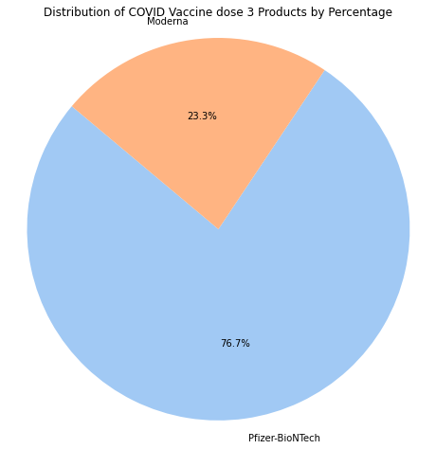
15. Distribution of COVID Vaccine dose 4 Products by Percentage:

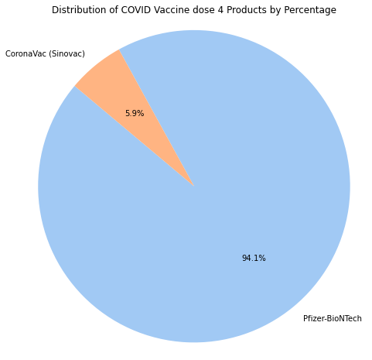
16. Distribution of COVID Vaccine dose 5 Products by Percentage:
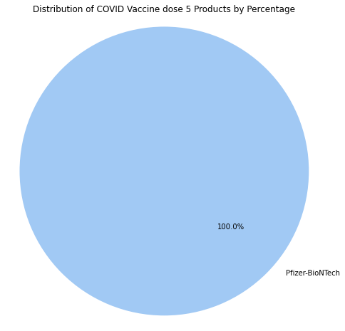
17. Post-Vaccination Recovery Rates: Fully Recovered vs. Not Recovered:
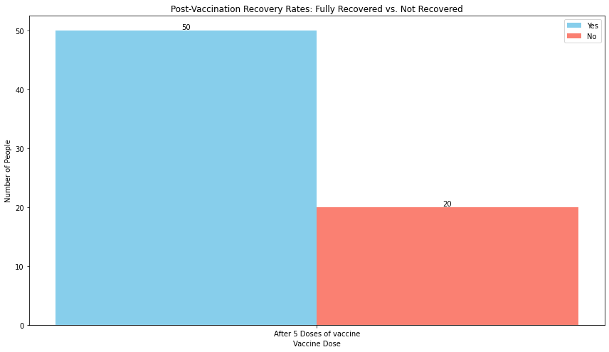

18. Occurrence of Major Symptoms in PASC Cases:
The chart displays the prevalence of various symptoms among individuals in PASC Cases
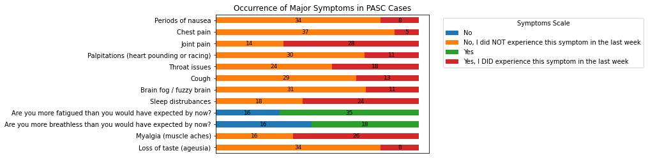
19. 'Association between Platelet Levels and Severe Headaches:
This box plot displays association between platelet levels and servere heaches
